Catholic University Of America
School of Engineering: EECS

Project 3-Digital Notch Filter Design
Due: 10:00Am on April 30, 2024

Design a second order digital notch filter to have a zero transmission at $250Hz$ and a sharp recovery of gain to unity on both sides of $250Hz$. The highest frequency to be processed is $ω_{h}^{'}=2π×500rad/s$.
(a) Draw the diagram showing the placement of poles and zeros in the complex plane using Matlab.
(b) Compute $H(z)$ and $|H(e^{j})|.$
(c) Use Matlab to plot the magnitude and phase response of the filter function of the digital frequency (rad/sample).
Hint: Your design should have a parameter “a”. Typical values are: $[0.95 0.6 0.3]$ as shown in figure below.
(d) Draw the canonical realization diagram of such a filter.
(e) For which value of the parameter “a” you get better selectivity for your notch filter?
Typical Output for part (a) and (c):
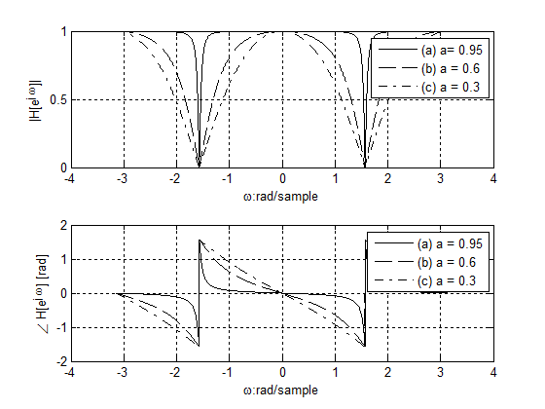
Submit a report by email: nehmetallah@cua.edu, showing all the necessary calculation, the necessary figures and the code in one pdf file. The name of the submitted pdf file should be your name.
You have to work alone. You can’t share your code or results in anyway with other students. You can’t use internet or any other source to do the project except class notes and code provided to you on blackboard.

